**TJD GUI – User Guide**

1. The first step before using TJD is to **modify the parameters_distanceS.m** file. Here you will specify the computer name, animal name, directories, hole and track number, etc., as shown in the figure below. **The variable called “x.list_data_name” must not be modified** as it will be updated according to the animal’s name specified before.

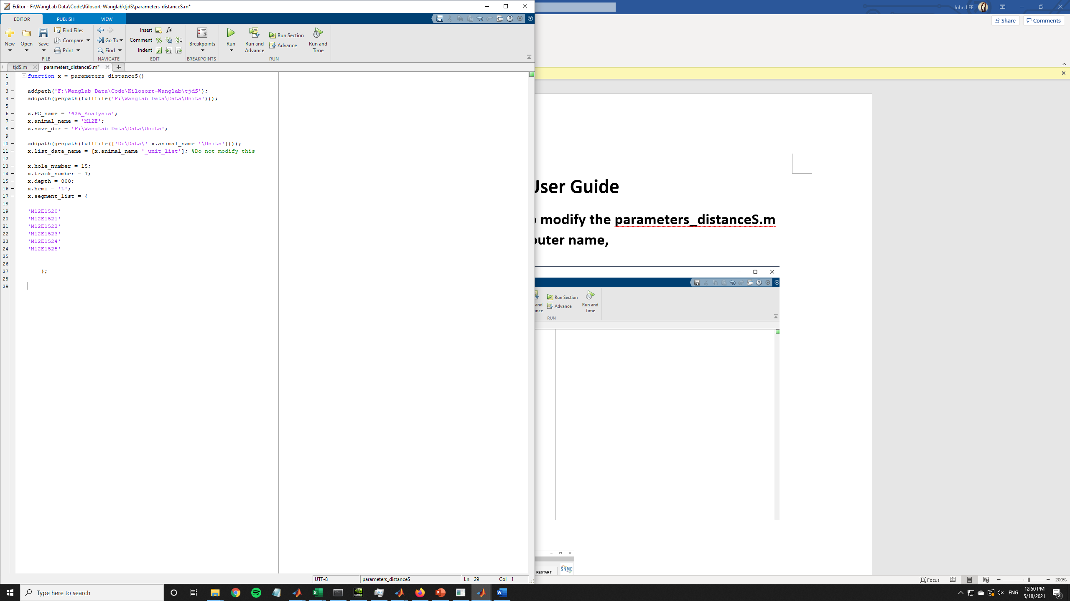

1. After modifying the parameters file, now you can proceed and run the TJD code. After initializing the TJD code and running the Cdistance function, the TJD GUI will pop up and you will see the screen of the figure below. As you can see most of the buttons are locked in order to prevent user errors.

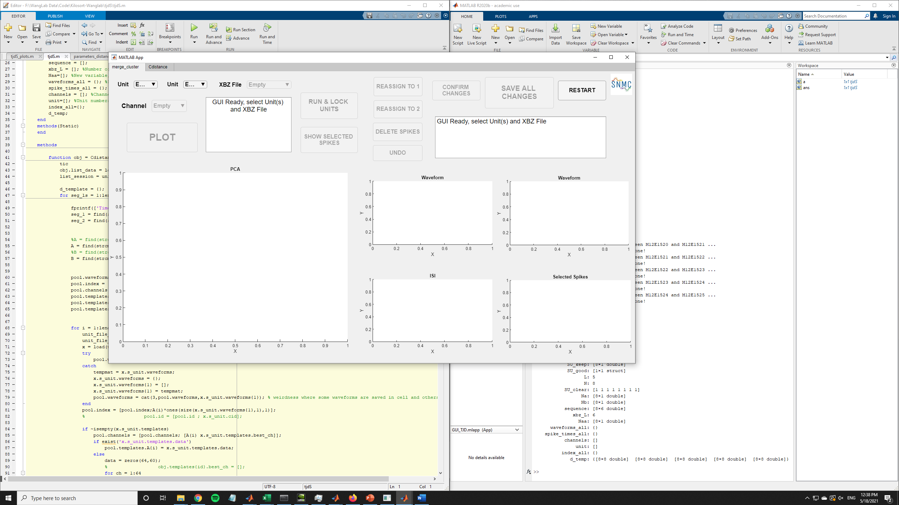

1. The GUI consists of 2 windows: one for the manual modification/quality analysis of clusters (figure above) and one for the visualization of cluster distances (figure below).

